**EXP NO 5** Create a simple cloud software application for Mark Sheet Processing System using any Cloud Service Provider to demonstrate SaaS include the necessary fields such as name of the student, Reg no of the student, Subjects, Marks, Average, percentage, rank, overall performance etc.

**AIM:**

TO create a simple cloud software application for mark sheet processing system using any cloud service provider to demonstrate saas.

**PROCEDURE:**

**STEP1:** GOTO ZOHO.COM STEP

**STEP2:** LOGIN TO THE ZOHO.COM STEP

**STEP 3**: SELECT ONE APPLICATION STEP

**STEP 4:** ENTER APPLICATION NAME STEP

**STEP 5:** CREATED NEW APPLICATION STEP

**STEP 6:** SELECT ONE FORM STEP

**STEP 7:** THE SOFTWARE HASE BEEN CREATED

**STEP 1** GO TO ZOHO.COM

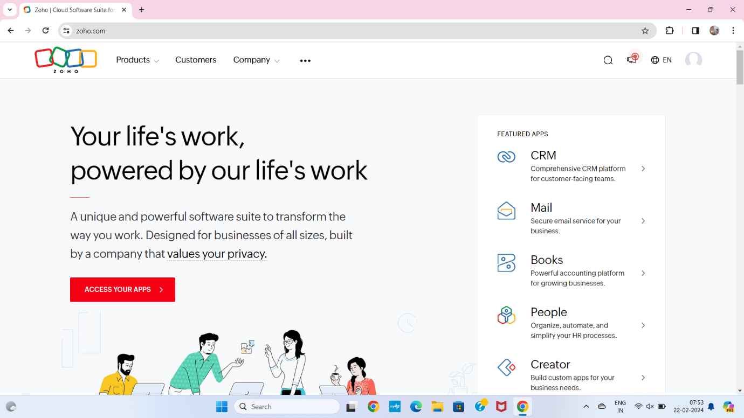

**STEP2** LOGIN TO THE ZOHO.COM

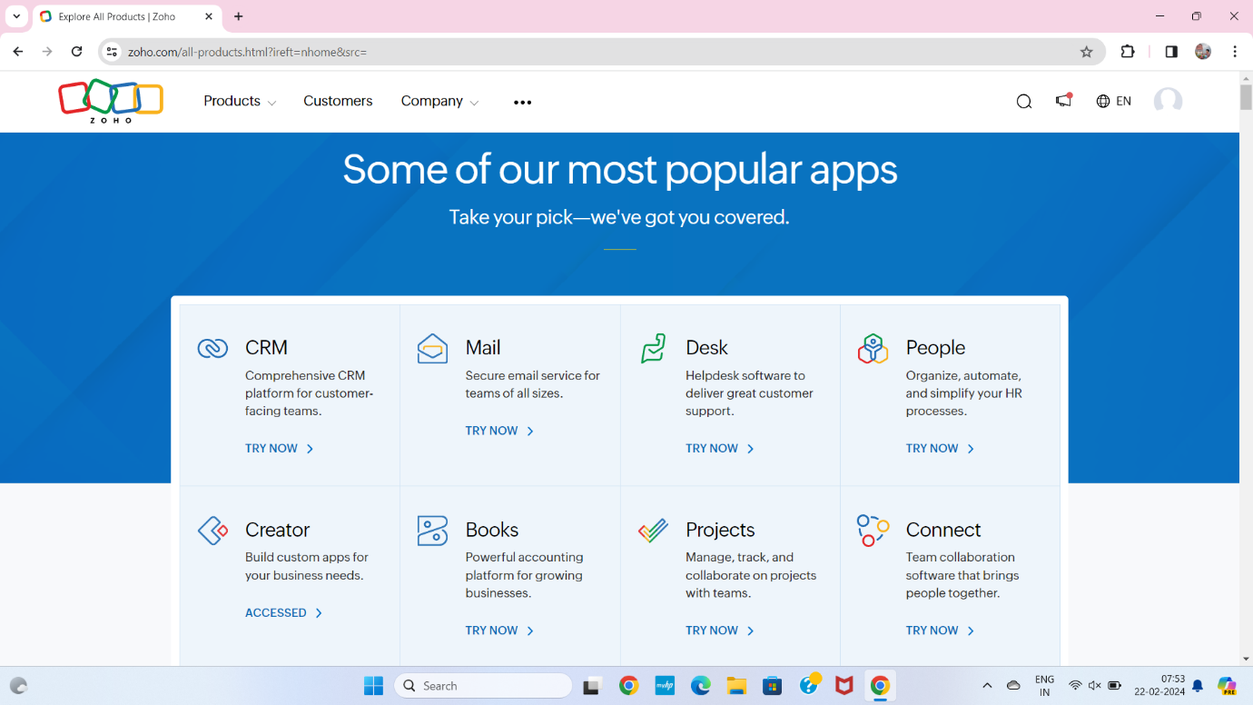

**STEP 3** SELECT A CREATE FROM SCRATCH

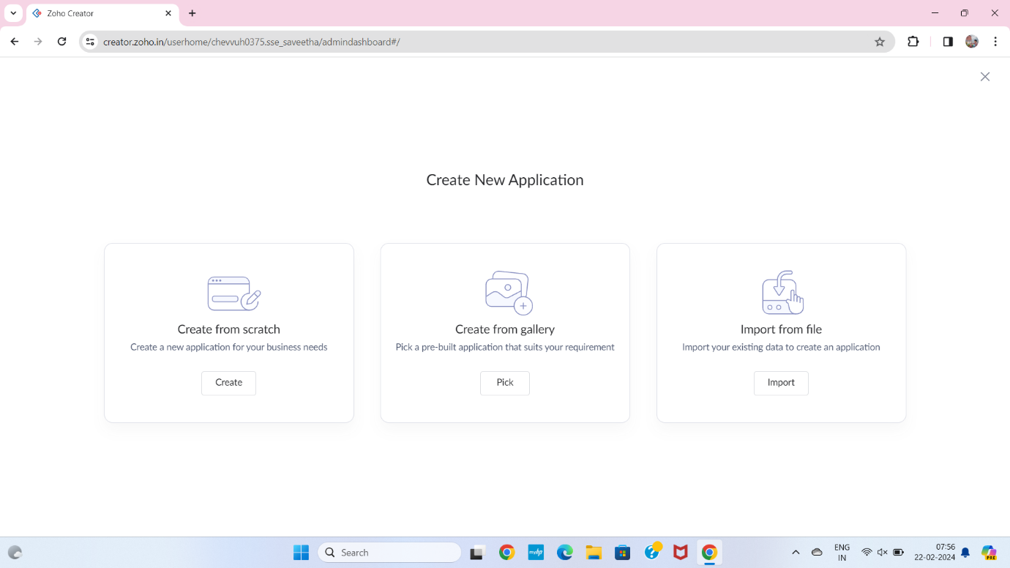

**STEP 4** SELECT APPLICATION NAME AS PROPERTY BUYING AND RENTAL

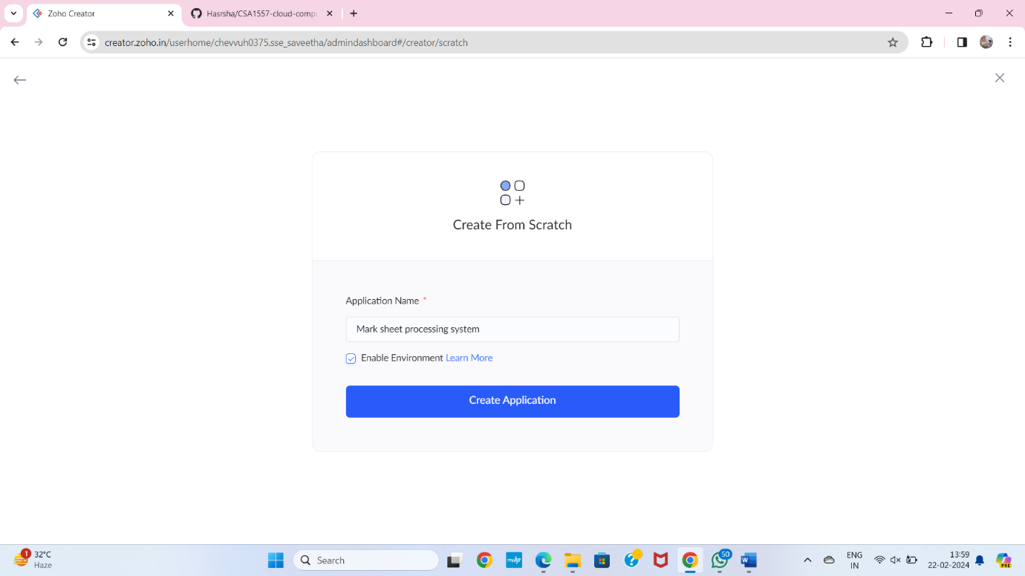

**STEP 5** CREATE A NEW FORM

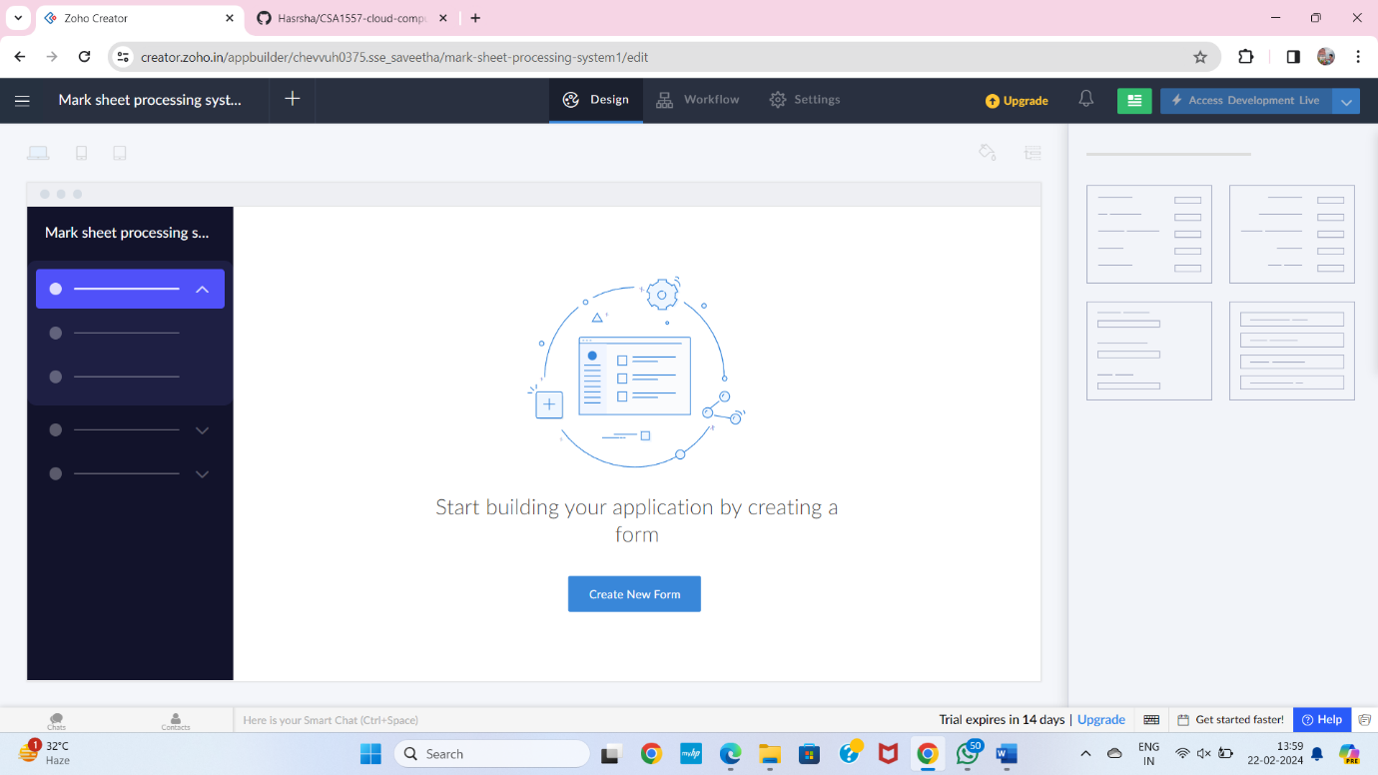

**STEP 6** SELECT BASIC FIELD FROM GIVEN BELOW AND DEVELOP APPLICATION

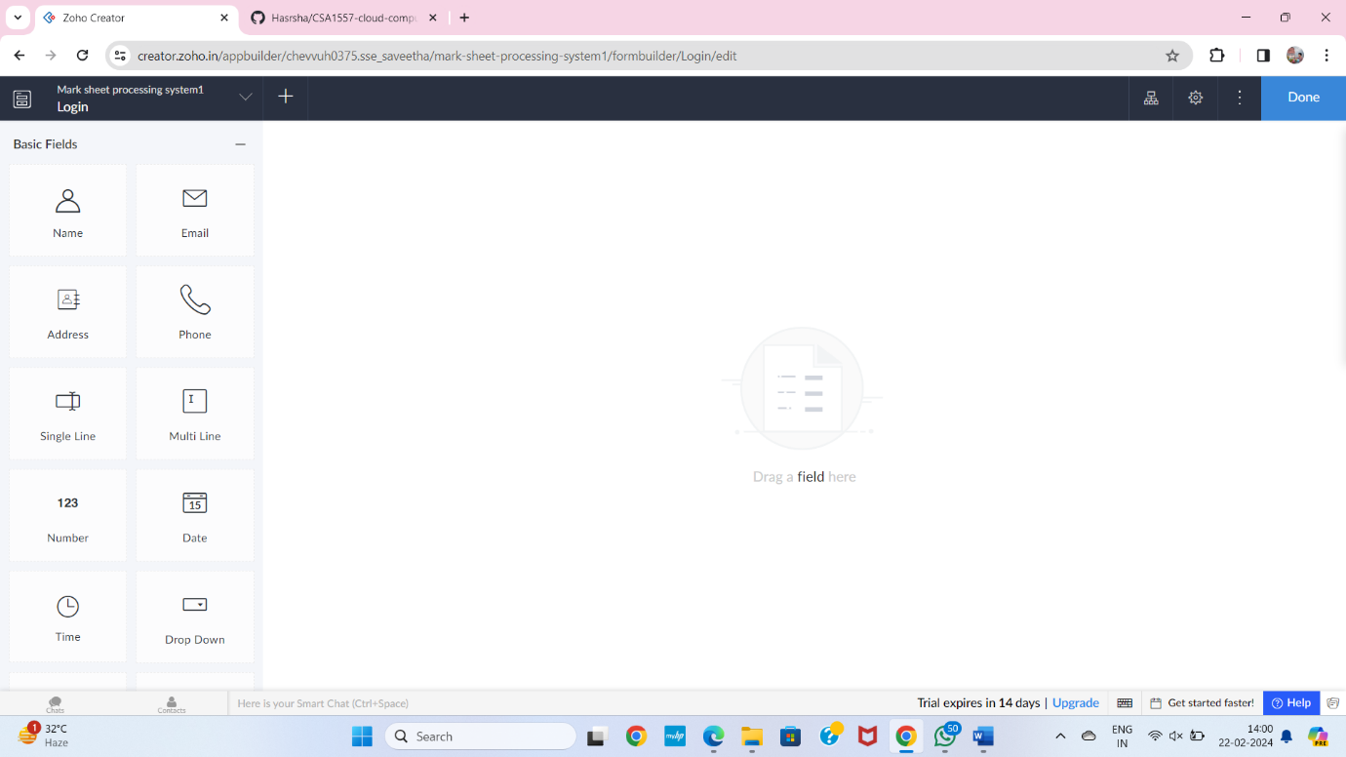

**STEP 7** THE SOFTWARE HASE BEEN CREATED LOGIN PAGE

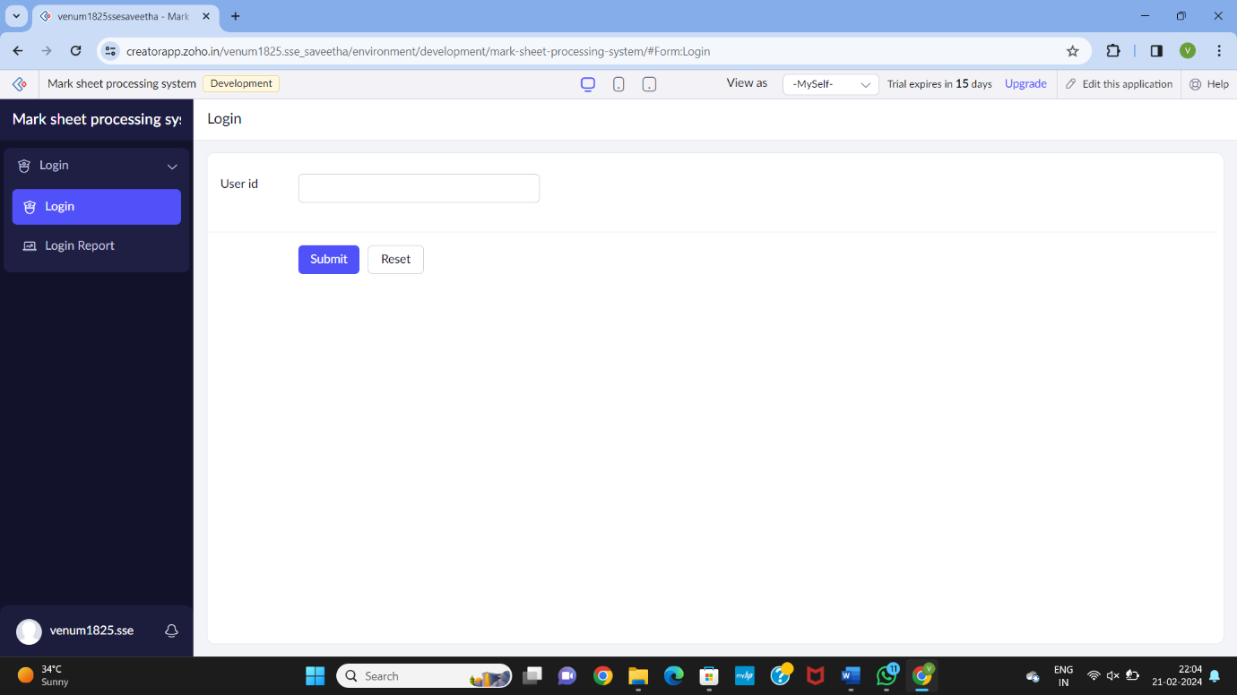

**STEP 8** THE SOFTWARE HASE BEEN CREATED DETAILS OF STUDENT SUBJECT MARKS

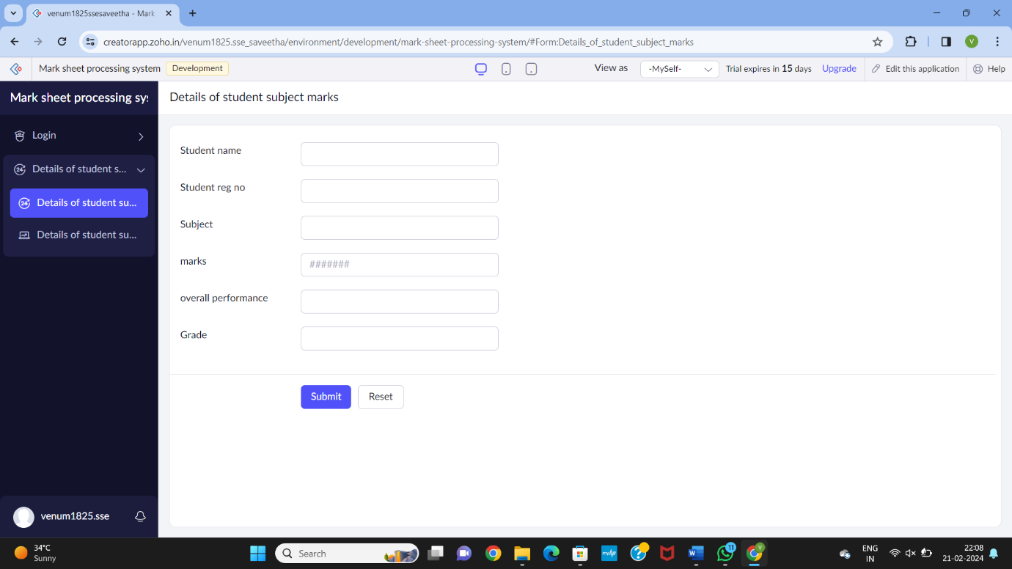

**STEP 9** THE SOFTWARE HASE BEEN CREATED DISCUSSION WITH PARENTS

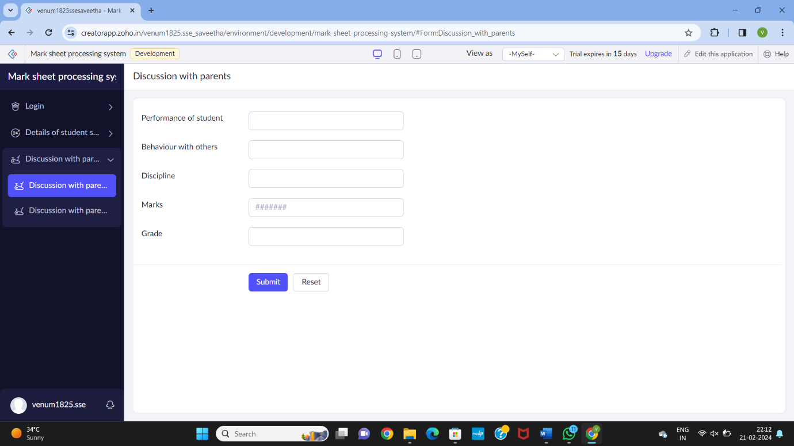

**STEP 10** THE SOFTWARE HASE BEEN CREATED EXEL

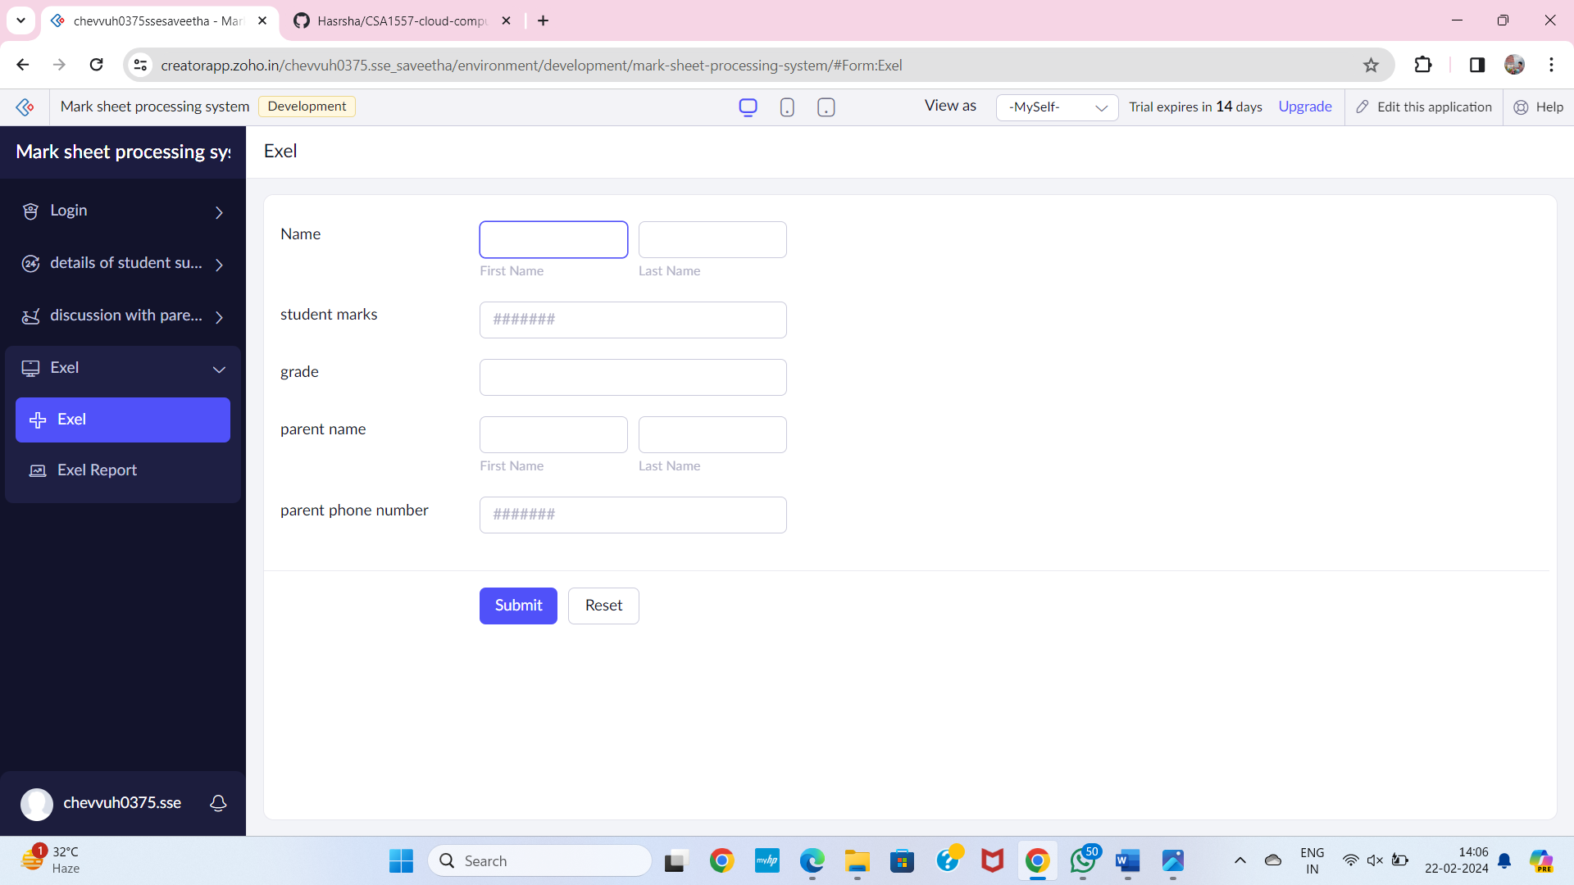

**STEP 11** THE SOFTWARE HASE BEEN CREATED

